UNITED STATES
SECURITIES AND EXCHANGE COMMISSION
Washington, D.C. 20549

SCHEDULE 14A
(RULE 14a-101)

INFORMATION REQUIRED IN PROXY STATEMENT
SCHEDULE 14A INFORMATION

Proxy Statement Pursuant to Section 14(a) of the
Securities Exchange Act of 1934
(Amendment No. &numsp;&numsp;&numsp;&numsp; )

Filed by the Registrant ☒

Filed by a party other than the Registrant ☐

Check the appropriate box:

☐ | Preliminary Proxy Statement

☐ | Confidential, for Use of the Commission Only (as permitted by Rule 14a-6(e)(2))

☐ | Definitive Proxy Statement

☒ | Definitive Additional Materials

☐ | Soliciting Material Pursuant to §240.14a-12

Cracker Barrel Old Country Store, Inc.
(Name of Registrant as Specified In Its Charter)

(Name of Person(s) Filing Proxy Statement, if Other Than The Registrant)

Payment of Filing Fee (Check the appropriate box):

☒ | No fee required.
☐ | Fee paid previously with preliminary materials.
☐ | Fee computed on table in exhibit required by Item 25(b) per Exchange Act Rules 14a-6(i)(1) and 0-11

 | 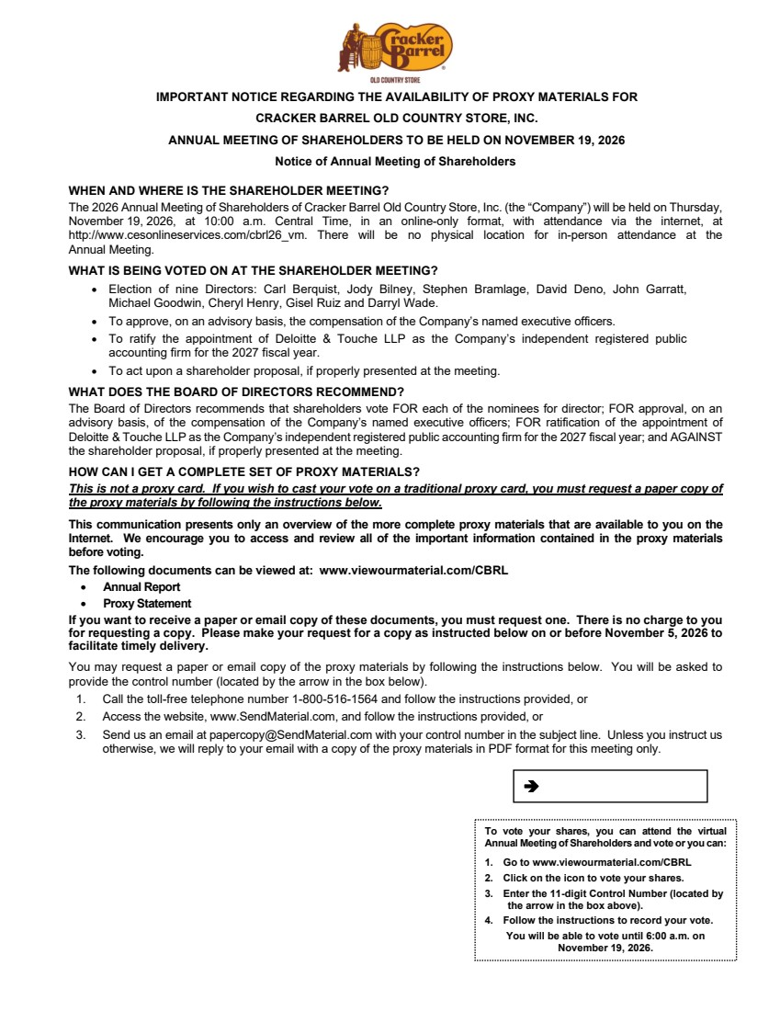 | To vote your shares, you can attend the virtual Annual Meeting of Shareholders and vote or you can: 1. Go to www.viewourmaterial.com/CBRL 2. Click on the icon to vote your shares. 3. Enter the 11-digit Control Number (located by the arrow in the box above). 4. Follow the instructions to record your vote. You will be able to vote until 6:00 a.m. on November 19, 2026. IMPORTANT NOTICE REGARDING THE AVAILABILITY OF PROXY MATERIALS FOR CRACKER BARREL OLD COUNTRY STORE, INC. ANNUAL MEETING OF SHAREHOLDERS TO BE HELD ON NOVEMBER 19, 2026 Notice of Annual Meeting of Shareholders WHEN AND WHERE IS THE SHAREHOLDER MEETING? The 2026 Annual Meeting of Shareholders of Cracker Barrel Old Country Store, Inc. (the “Company”) will be held on Thursday, November 19, 2026, at 10:00 a.m. Central Time, in an online-only format, with attendance via the internet, at http://www.cesonlineservices.com/cbrl26_vm. There will be no physical location for in-person attendance at the Annual Meeting. WHAT IS BEING VOTED ON AT THE SHAREHOLDER MEETING? • Election of nine Directors: Carl Berquist, Jody Bilney, Stephen Bramlage, David Deno, John Garratt, Michael Goodwin, Cheryl Henry, Gisel Ruiz and Darryl Wade. • To approve, on an advisory basis, the compensation of the Company’s named executive officers. • To ratify the appointment of Deloitte & Touche LLP as the Company’s independent registered public accounting firm for the 2027 fiscal year. • To act upon a shareholder proposal, if properly presented at the meeting. WHAT DOES THE BOARD OF DIRECTORS RECOMMEND? The Board of Directors recommends that shareholders vote FOR each of the nominees for director; FOR approval, on an advisory basis, of the compensation of the Company’s named executive officers; FOR ratification of the appointment of Deloitte & Touche LLP as the Company’s independent registered public accounting firm for the 2027 fiscal year; and AGAINST the shareholder proposal, if properly presented at the meeting. HOW CAN I GET A COMPLETE SET OF PROXY MATERIALS? This is not a proxy card. If you wish to cast your vote on a traditional proxy card, you must request a paper copy of the proxy materials by following the instructions below. This communication presents only an overview of the more complete proxy materials that are available to you on the Internet. We encourage you to access and review all of the important information contained in the proxy materials before voting. The following documents can be viewed at: www.viewourmaterial.com/CBRL • Annual Report • Proxy Statement If you want to receive a paper or email copy of these documents, you must request one. There is no charge to you for requesting a copy. Please make your request for a copy as instructed below on or before November 5, 2026 to facilitate timely delivery. You may request a paper or email copy of the proxy materials by following the instructions below. You will be asked to provide the control number (located by the arrow in the box below). 1. Call the toll-free telephone number 1-800-516-1564 and follow the instructions provided, or 2. Access the website, www.SendMaterial.com, and follow the instructions provided, or 3. Send us an email at papercopy@SendMaterial.com with your control number in the subject line. Unless you instruct us otherwise, we will reply to your email with a copy of the proxy materials in PDF format for this meeting only.
 | 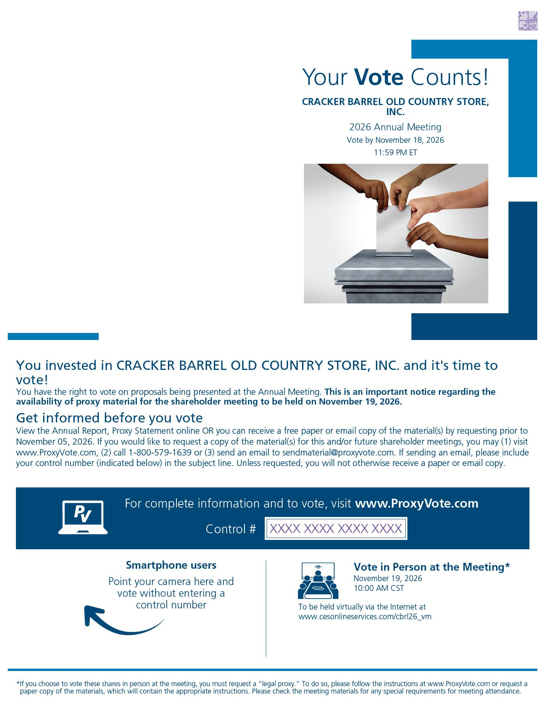 | Get informed before you vote *If you choose to vote these shares in person at the meeting, you must request a “legal proxy.” To do so, please follow the instructions at www.ProxyVote.com or request a paper copy of the materials, which will contain the appropriate instructions. Please check the meeting materials for any special requirements for meeting attendance. Smartphone users Point your camera here and vote without entering a control number Your Vote Counts! FLASHID-JOB# For complete information and to vote, visit www.ProxyVote.com Control # Ricky Campana P.O. Box 123456 Suite 500 51 Mercedes Way Edgewood, NY 11717 148,294 322,224 1 OF 2 30# Hextone, Inc. P.O. Box 9142 Farmingdale, NY 11735 XXXX XXXX XXXX XXXX CRACKER BARREL OLD COUNTRY STORE, INC. 2026 Annual Meeting Vote by November 18, 2026 11:59 PM ET You invested in CRACKER BARREL OLD COUNTRY STORE, INC. and it's time to vote! You have the right to vote on proposals being presented at the Annual Meeting. This is an important notice regarding the availability of proxy material for the shareholder meeting to be held on November 19, 2026. View the Annual Report, Proxy Statement online OR you can receive a free paper or email copy of the material(s) by requesting prior to November 05, 2026. If you would like to request a copy of the material(s) for this and/or future shareholder meetings, you may (1) visit www.ProxyVote.com, (2) call 1-800-579-1639 or (3) send an email to sendmaterial@proxyvote.com. If sending an email, please include your control number (indicated below) in the subject line. Unless requested, you will not otherwise receive a paper or email copy. Vote in Person at the Meeting* November 19, 2026 10:00 AM CST To be held virtually via the Internet at www.cesonlineservices.com/cbrl26_vm
 | 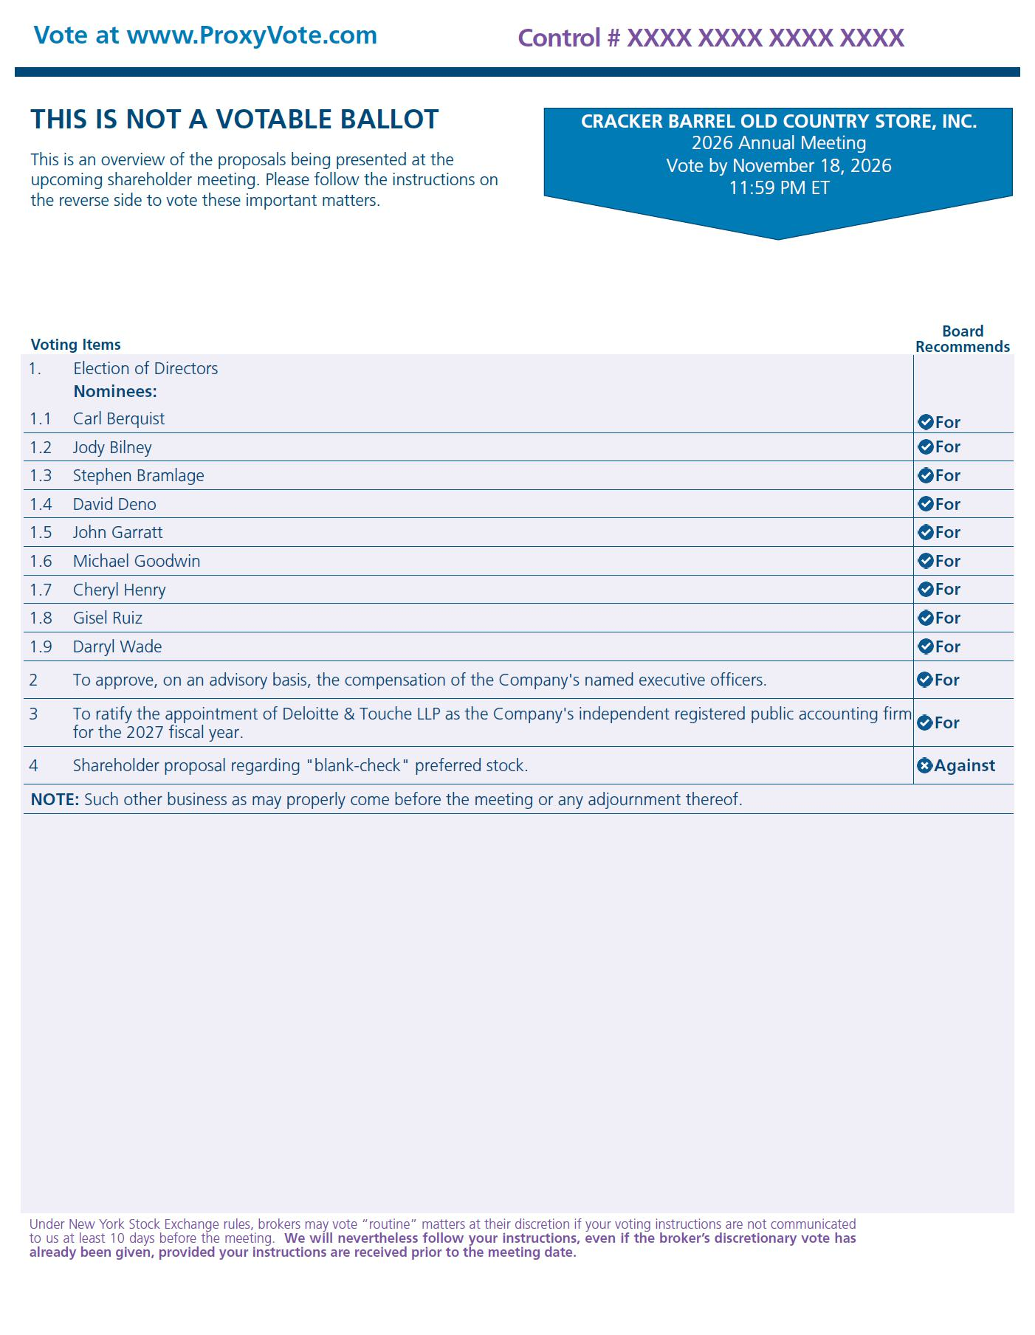 | Voting Items Board Recommends THIS IS NOT A VOTABLE BALLOT This is an overview of the proposals being presented at the upcoming shareholder meeting. Please follow the instructions on the reverse side to vote these important matters. Vote at www.ProxyVote.com FLASHID-JOB# Control # XXXX XXXX XXXX XXXX 1.00000 322,224 148,294 Under New York Stock Exchange rules, brokers may vote “routine” matters at their discretion if your voting instructions are not communicated to us at least 10 days before the meeting. We will nevertheless follow your instructions, even if the broker’s discretionary vote has already been given, provided your instructions are received prior to the meeting date. CRACKER BARREL OLD COUNTRY STORE, INC. 2026 Annual Meeting Vote by November 18, 2026 11:59 PM ET 1. Election of Directors Nominees: 1.1 Carl Berquist For 1.2 Jody Bilney For 1.3 Stephen Bramlage For 1.4 David Deno For 1.5 John Garratt For 1.6 Michael Goodwin For 1.7 Cheryl Henry For 1.8 Gisel Ruiz For 1.9 Darryl Wade For 2 To approve, on an advisory basis, the compensation of the Company's named executive officers. For 3 To ratify the appointment of Deloitte & Touche LLP as the Company's independent registered public accounting firm for the 2027 fiscal year. For 4 Shareholder proposal regarding "blank-check" preferred stock. Against NOTE: Such other business as may properly come before the meeting or any adjournment thereof.

